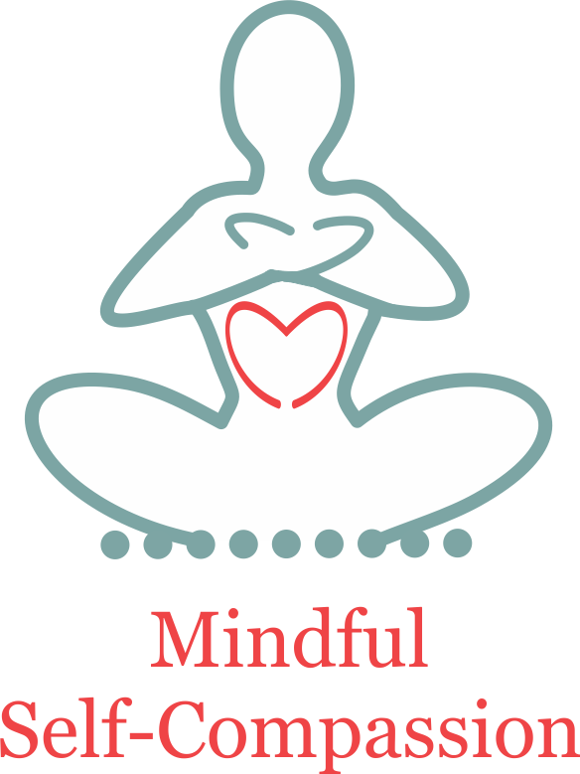
MINDFUL SELF-COMPASSION
Background Information

Please note: This information will only be read by the course instructors. If you feel uncomfortable answering any questions, please note that on the form and we can have a private conversation before the program begins. Thank you.

Name:
Address:
Email:
Phone: (h) (w) (c)
Gender: female male
Date of Birth: Age:
Partnership status: Single Married Divorced Partnered Other
Occupation:
Education: High School College Graduate Other
Where did you find out about the MSC training?
Why are you interested in participating in this program? (Please be advised that MSC is designed for personal growth and development.)

Do you have a regular practice of meditation? If so, what type and how many years have you been practicing? (It’s not necessary to have any experience of meditation prior to this program.)

How would you describe your physical health: excellent good fair poor
Are you currently in psychotherapy? (If so, please provide the name and telephone number of your therapist.)

Are you currently taking psychoactive medication, or any medication that may affect how you feel from one week to the next? (If so, please provide details.)

Is there anything else that would be helpful for the instructors to know at this time?

I understand that my participation in this program is entirely voluntary and I am free to withdraw at any time without penalty or prejudice, except for the non-refundable course fee. At the present time, however, I am planning to participate in the entire course (including the retreat), and to practice mindful self-compassion at least 30 min/day (formally or informally).

Name: Date:

